**Title**: Searching for exoplanets: A high-school summer project

**Author**: Amaan Syed Azhar

**Abstract** This project explores the detection of exoplanets through the analysis of light curves, done by a high school student with a passion for astronomy and data science. Utilizing data from the MAST archive, specifically focusing on red giant stars due to their bright, rapidly orbiting planets, the project employs Python to analyze stellar luminosity patterns. By comparing known exoplanetary systems, such as KIC 6922244, with unexplored stars, the project aims to identify potential exoplanets. The analysis revealed exoplanet-like patterns in two stars, TIC 88928093 and TIC 445501347, though limitations in confirming these findings highlight the challenges faced by amateur astronomers.

**Keywords**: Exoplanets, lightkurve, MAST dataset, ExoMAST, luminosity.

**Introduction**:

I am a high school student with an interest in astronomy and more specifically, cosmology. To understand the work that astronomers do, I decided to undertake this project. I have data science knowledge, and I thought that running some sort of data analysis about universal bodies would be an interesting concept.

The Mikulski Archive for Space Telescopes (MAST) is a NASA funded project to support and provide to the astronomical community a variety of astronomical data archives, with the primary focus on scientifically related data sets in the optical, ultraviolet, and near-infrared parts of the spectrum. ExoMAST is a website used to further filter and identify what the data on MAST can explain to us. Tess is a MIT-led NASA mission discovering transiting exoplanets via an all-sky survey. The reason that the star used that already was checked had a “KIC” instead of a “TIC” is because KIC is simply a bank of analyzed data.

**Methods**

Using code written by Mikael Codes on YouTube, an exoplanet finder was made and used for this project. This process was done by going to the MAST dataset and checking the Tess CTL catalogs advanced search. The data was then refined to only have red giants, as those tend to have rapidly orbiting planets which are very bright. This makes looking for exoplanets via the process of looking at light curves much easier. After taking its id and checking in ExoMAST if the star had already been looked at, we put it back in MAST search and download the data files. After plugging it in, we use the Python libraries “numpy” and “lightkurve” to analyze the data. By looking at the patterns noticed in the graphs of stars that we know have exoplanets and comparing them to stars that haven’t been looked at before, we understand if they have exoplanets or not. As a planet passes in front of a star, the luminosity of the star would decrease. This is something we can see and graph using the lightkurve and numpy libraries. The graphs created as an example for KIC 6922244 were recreated for 4 other iterations.

**Results**

Having repeated this process quite a few times, some remarkable things were noticed. If a planet was not noticed, it is possible that it was due to the sampling time of the telescope wasn’t long enough to notice them. KIC 6922244 is a star that has been studied already, so we know that it has an exoplanet. Shown below are the graphs that the data analysis was able to create.

*KIC 6922244*

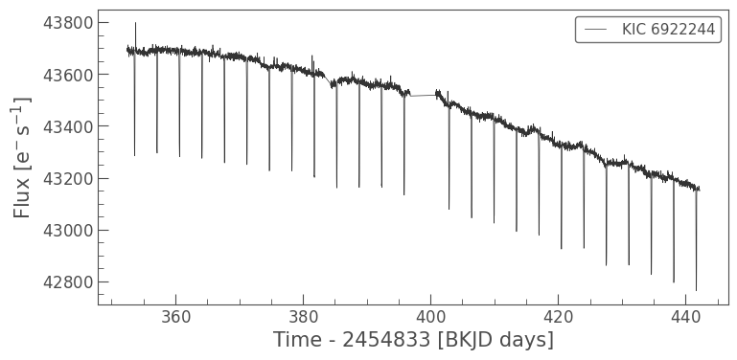

Figure 1: Flux time chart for KIC 6922244

The graph 1 above has no changes or filters applied to it; it simply shows the raw data.

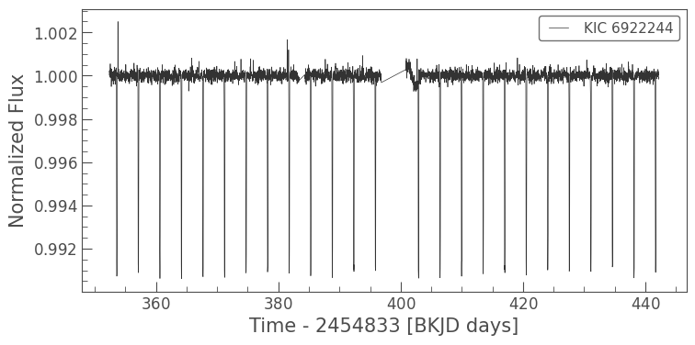

Figure 2Flux time chart for KIC 6922244 (flattened)

The graph 2 above has been flattened so that there is no general downward decreasing trend and shows only the spikes.

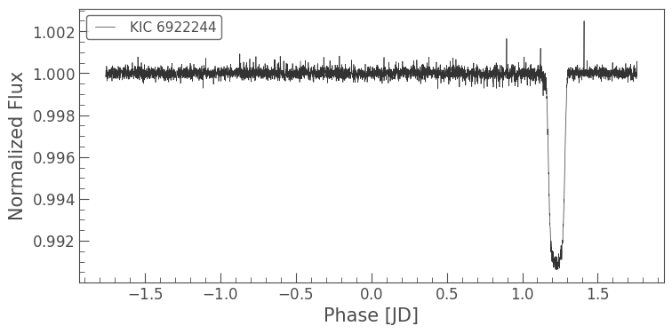

Figure 3Flux time chart for KIC 6922244 (flattened, condensed)

The graph 3 above has condensed all the spikes into one big spike, showing how much luminosity was lost by the orbit of the exoplanet.

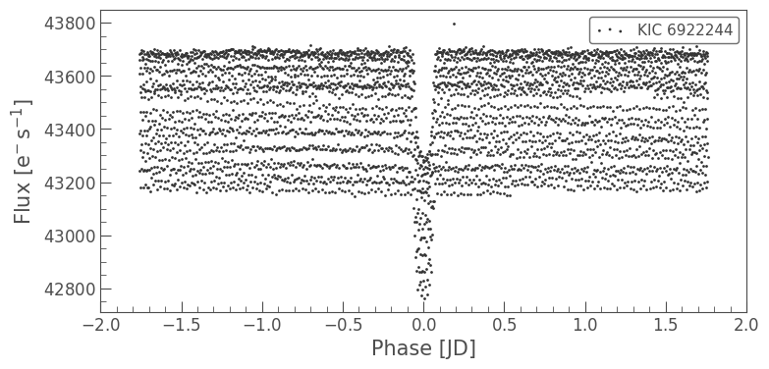

Figure 4 Scatterplot of flux phase for KIC 6922244

The graph 4 above contains the same data, however showcased in a scatterplot this time.

By keeping these graphs in mind, we can see what an orbiting exoplanet should look like in our analysis of the data. This search was also conducted by looking at 4 other stars, each with their own unique patterns.

**Discussion**

Within 5 iterations with different datasets, I was successfully able to find an exoplanet in TIC 88928093 and TIC 445501347. TIC 88928093 seems to contain a reverse pattern, having the planets normal luminosity be quite low, and periodically spike up. This could be telling of an asteroid belt, or, alternatively, an exoplanet. TIC 445501347’s graphs were very similar to a sine graph, which is indicative of a fast-orbiting exoplanet.

There has been an exponential increase in the discovery of exoplanets recently. This has been due to an increased due to the launch of the Kepler Space Telescope, which has also resulted in a huge increase in the information available to the public.

This work has some limitations. I was unable to directly confirm whether my findings are indeed exoplanets, as that is completely out of my budget and knowledge. We can only make educated guesses with this method.

**Supplementary materials**

My Little Exoplanet Finder – collab.pdf

Url: github.com/myfleshburns/

**References**

**CODE USED:** [**https://www.youtube.com/watch?v=6s1LlzMNp78&t=2s**](https://www.youtube.com/watch?v=6s1LlzMNp78&t=2s)

[**https://colab.research.google.com/drive/1g1gsTtc-gZqOEHUGPz-nq2UCt4f8rai0?usp=sharing**](https://colab.research.google.com/drive/1g1gsTtc-gZqOEHUGPz-nq2UCt4f8rai0?usp=sharing)

**MAST:** [**https://mast.stsci.edu/portal/Mashup/Clients/Mast/Portal.html**](https://mast.stsci.edu/portal/Mashup/Clients/Mast/Portal.html)

**ExoMAST:** [**https://exo.mast.stsci.edu**](https://exo.mast.stsci.edu)